Northeastern Maryland Intergroup of Alcoholics Anonymous
Intergroup Council Monthly Meeting
Date: April 28, 2026
The chair called the meeting to order at 7:05 pm with the Serenity Prayer. The roll call followed.
Attendance: Total: 17
In-person:
Officers (3): Council Chair (representing Three Legacies Group), Secretary (IGR Emmorton Group), Treasurer
IGRs, Committee chairs, and members (5): IGR Gates of Insanity, IGR Rule 62 Group, IGR Three Legacies, IGR Young and the Restless, Events Committee chair

On Zoom/phone:
Officers (0):
IGRs, Committee chairs, and members (9): IGR Forest Hill Tuesday Night, IGR Good News Group, IGR Good Orderly Direction, IGR North East 12 & 12, IGR North East Big Book, IGR Pursuit of Happiness, Institutions Committee chair, Intergroup office coordinator, Visitor

Council chair report: Not much to report other than our focus over the next months will be the position rotation, and Events chair will speak to the breakfast later in the meeting.
Secretary’s report: The secretary presented the March 2026 minutes and asked for amendments. Two amendments were submitted prior to the meeting: treasurer wrongly identified as attending via Zoom and an incorrect date in the events calnedar. There was a motion to accept the minutes as amended. March minutes accepted unanimously.
Treasurer’s report: The treasurer presented a summary of the council’s financial reports as of March 31, 2026:
Account balances are:
- Operating Account: $9,483.32
- PayPal Account: $194.95
- Prudent Reserve Account: $23,814.06
Revenue:
- Group Contributions thru March is $ 5,387.58
- Individual Contributions & Birthday Plan is $654.37
- Office Events total $11,941.00
- Literature & Medallion Sales total $ 3,950.67
- Interest income totals $.59
Total Revenue is $21,933.62 which is 36% of our budgeted revenue for 2026.
Expenses:
Through March, we have paid out a total of $15,275.04 which is 25% of our budgeted expenses
this year.
There was a motion to accept the report as presented and a second. The treasurer’s report was accepted unanimously.
The chair stated we’re in good shape and the treasurer noted bingo and the breakfast were very successful.
Office coordinator report: Has a list of things we take to the breakfast now, so will be better prepared next time. Sold $114.10 in literature, pamphlets, and medallions at the breakfast. Is experience one issue with Ontario Printing not delivering the Step 10 checklist. Events chair will get with office coordinator after the meeting.
The Council chair noted that from March 1 to April 25 the we averaged a bit over 1 phone call daily when office is open and foot traffic had a daily increase of 3.16 on average, with most activity on Tuesdays and Fridays.
We’d been hovering around 2 daily visitors.
Standing and ad hock committee reports
Finance (standing): (position open)
Answering service (standing): The committee chair was unable to attend. No report.
Institutions (standing): The committee chair is starting to compile a list of senior centers and facilities in Harford and Cecil counties. There is someone interested as filling in as Institution Committee chair when jobs rotate and current chair has interest in CPC/PI position when we rotate. Filled one of the two open Fridays for Brantwood facility commitment in Elkton. Still looking for one woman to fill the 1x per month.
Website/technology (standing): The committee chair was unable to attend. No report. Council chair thinks we had some updates to the system over the last weeks to improve site security.
Events (ad hoc): The committee chair shared note that to their knowledge we’re not buying the big version of the tickets on the website but will still be able to sell tickets virtually.
After reconciling funds for the breakfast, we made a little over $2,600. The committee chair requested we make a $100 donation to the fire hall for being so nice to us. Approved by Council chair.
The treasurer recommended paying the amount taken out of the original cost—$400. Approved by Council chair.
When negotiating the April 2026 plate prices, it wasn’t revealed what was taken out of the breakfast—thus missing pancakes. The chair has negotiated $17 plates for the next breakfast and confirmed pancakes are included.
The chair would like to request the fall breakfast ticket price remain $20.
For April, we sold 230 tickets and 185 people attended. The 50/50 was about $750.
In the fall we will use long tables, rather than round, and set for 240. The Solution for Living group will be hosting the fall breakfast. Event coordinator should be in touch with them at 8 weeks out.
The chair will be posting a notice seeking a group to host the 2027 spring breakfast at a date convenient to the group in late March or early April.
Q: What does it mean to host?
A: Distribute and track tickets; staff the breakfast for some things—taking tickets, handling 50/50; get the speaker; MC; and those sorts of activities. The Events Committee chair handles behind the scenes such as license, breakfast costs.
The chair originally budgeted $500 for the June picnic and already has 4 people to help with the picnic.
Janie L. is interested in taking on activity with the picnic to get an idea of what the Events Committee and the committee chair do before considering any nomination to the chair or other committee position.
The chair requested being given a volunteer email address with the Intergroup after stepping down so they can still help out with the bulletin and email.
The Council chair thanked the Events Committee chair for all their activity and effort.
Events calendar:
What | When | Where | Cost
Spring Breakfast * | Sun - April 26th, 8-12 am | Level Hall Firehouse, HdG | $20
D11 - “Our Primary Purpose” Workshop | Sat - May 9th, 10-1:30 pm | W. Nottingham Presbyterian Church, Colora | Free
Spring Fling * | Sat - May 16th, 7-11 pm | W. Nottingham Presbyterian Church, Colora | $10
Picnic at Deer Creek | Sat - June 6th, 11-3pm | Deer Creek Picnic Area, HdG | Free
Rock N Bowl * | Sat – July TBD, 7-9:30pm | Harford Lanes, Aberdeen | $20
Fall Breakfast * | Sun - Oct 18th, 8-12 am | Level Hall Firehouse, HdG | $20
TBD = To be determined
* Requires ticket purchase
Updated: 28 April 2026

CPC/PI: (position open)
Archives (ad hoc): Committee chair unable to attend. The chair provided a report read to the group by the secretary and attached to minutes.
Old Business
Upcoming officer elections. The Council chair noted that every two years the officers have to rotate out of the positions as part of the bylaws. At the breakfast the chair made a couple comments, read a joke about sponsorship, and tried to encourage breakfast attendees to express interest via email. Have not gotten any emails.

For the last rotation, no one was standing for Council chair. The current chair emailed the then chair to say if no one stepped up, he’d do it. And here he is.

There is precedent that the positions are not going to get a large influx of people.

In the past, the roles have been filled by the IGRs attending the monthly meeting. The chair is challenging the IGRs present to go back to their groups and get individuals to stand.

Treasurer puts in about 10 hours a month, secretary approximately 3–4, and the chair puts in about 10 hours a month as well. It’s not a lot of hours and anybody who steps up would have to be trained, in particular for treasurer. These are not necessarily a lot of work but we do need someone to come in and take the responsibility.

Actual job descriptions were previously distributed and also available via the bulletin.

This is great 12 Step work. The chair has enjoyed all three positions they’ve held over the years. If we’re to find a replacement, the chair thinks it’s going to come from the IGRs.

Q: Per the bylaws, is the requirement 2 years or 3 years?
A: The position is 2 years and requires a minimum 3 years’ sobriety.
New Business
Q: What was different about the breakfast that we made such improved attendance and income?
A: Event Committee chair thought the last several were still feeling the COVID-19 pandemic effects.

There was a motion to close, seconded, and no opposition.

Meeting adjourned at 7:45 pm and closed with the Responsibility Statement followed by the Lord’s Prayer.
NEMDAA Archive
28 Centennial Lane
Aberdeen, Maryland 21001

April 28, 2026, Report to Intergroup Council

The Gleanings Story Board, part of the larger Gleanings Project, is completed and ready for deployment. The story board consists of 22 boards: #1 and #2 shown here.
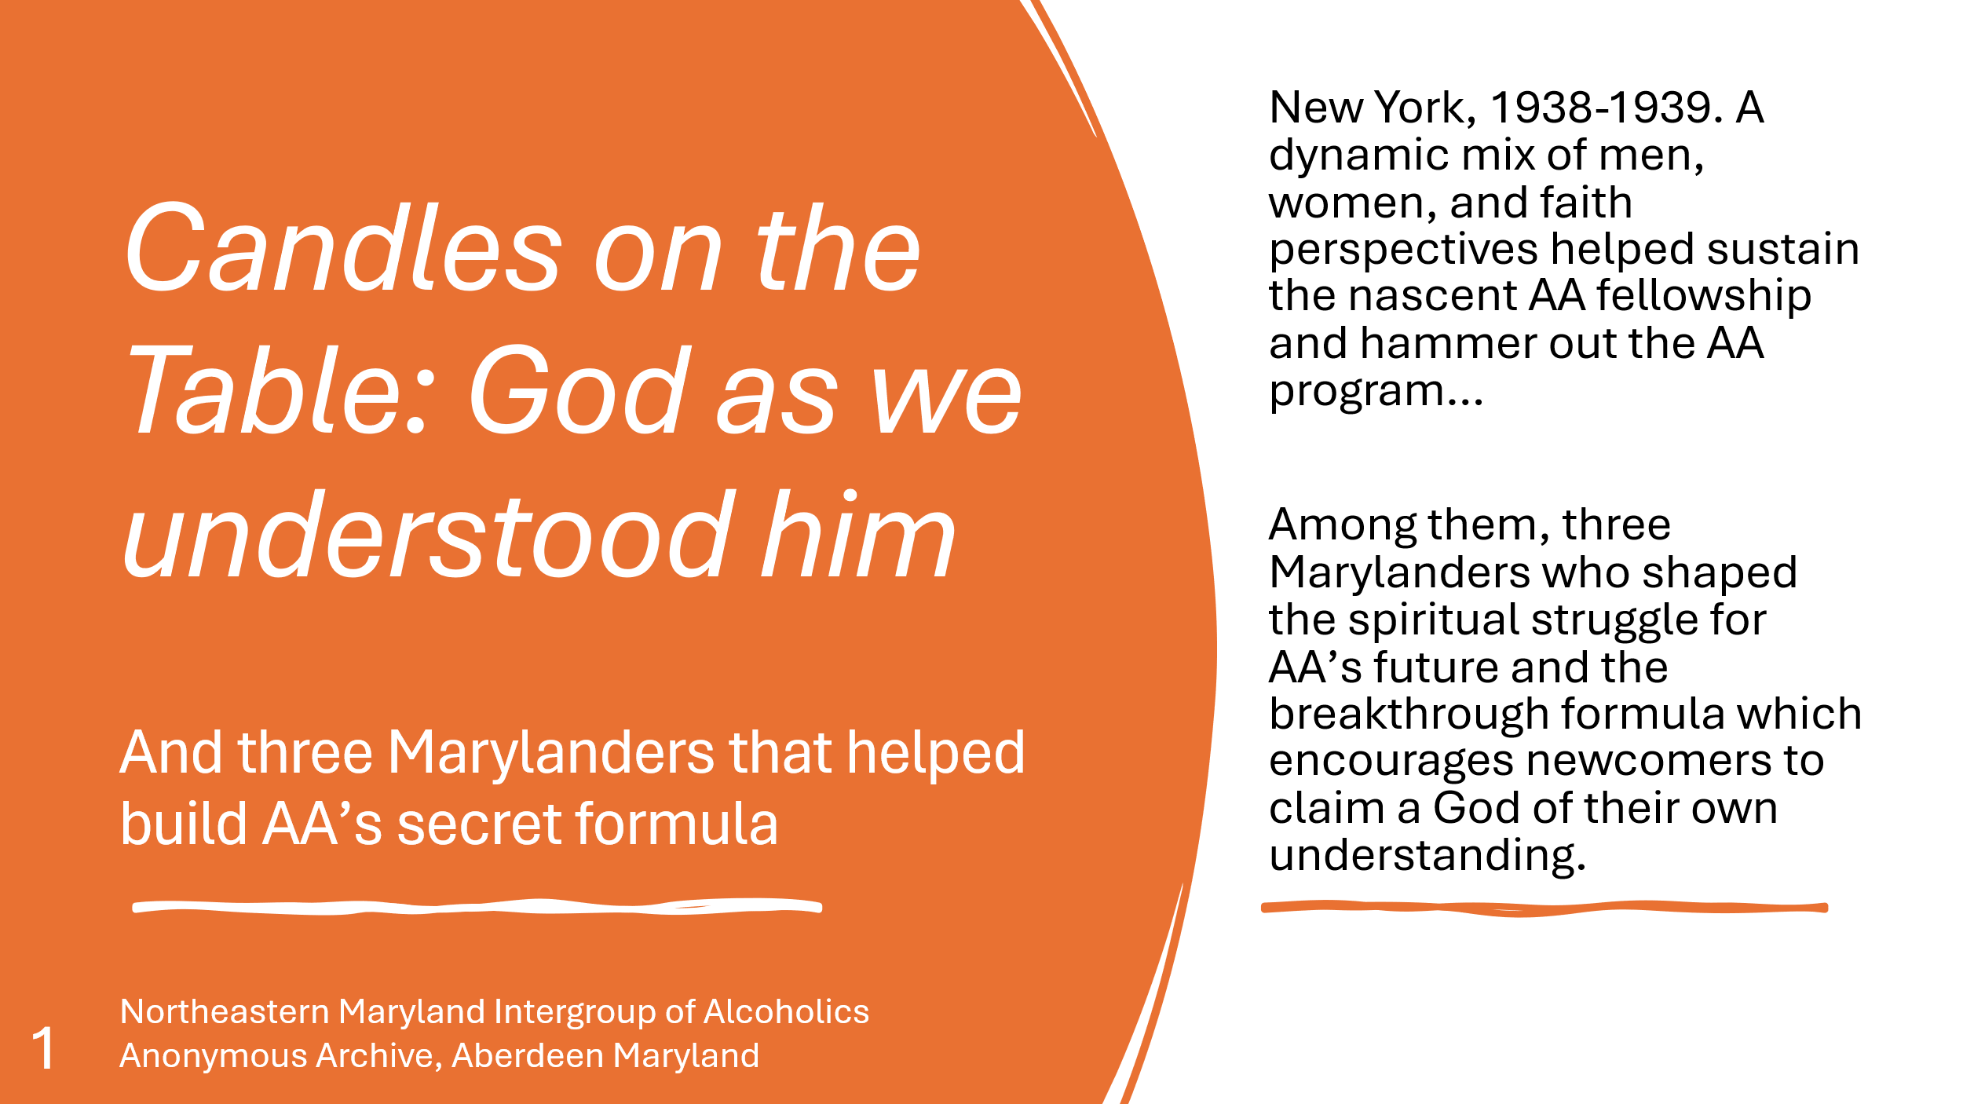 | 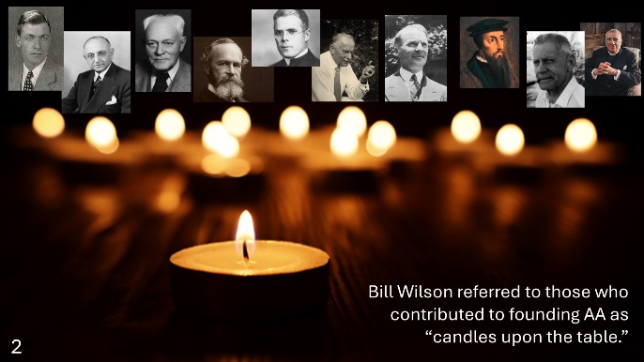
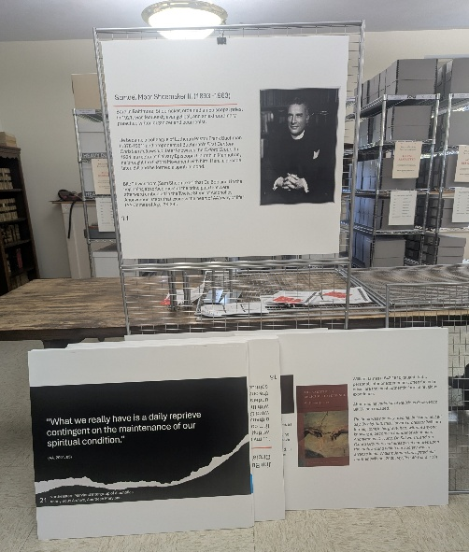
The boards can be displayed on the mobile wire frame system shown on the left. We can borrow the frame system from the Anthony J. Dougherty OSFS Archive in Childs with prior coordination. While the full story board does not have to be displayed, the expanded system permits the display of 28 (3’ x 2’) boards and can be supplemented by easels. The display can be arranged in various configurations with an average maximum wingspan of approximately 20± linear feet or roughly 100± square feet—permitting patrons to view panels on both sides of the display system.
I am seeking permission from Caleb T. to display the panels at the District 11 Workshop on May 8. Perhaps I can set it up for you for the May 26 Intergroup Meeting—outside if weather permits, or in front of the shop if not.
Mark P.
Archivist

