Are lntergroups & Central Offices a part of Alcoholics Anonymous?
"Although local Intergroups operate independently of our Fellowship's worldwide service structure, they are a vital part of A.A."
The A.A. Group pamphlet, page 35
"Traditionally, general service committees and Intergroup/Central Offices have performed different functions. Central offices provide local services; general service committees maintain the link between the A.A. Groups and the A.A. General Service Board by means of the Conference. So, these two separate but vital service structures co-exist in many areas in mutual cooperation and harmony."
"At the time the Conference was started, there were already well-established Central Offices in several large cities, providing services for local A.A. groups and members. Today, there are many more Central Offices located in the United States and Canada; supported by the A.A. groups in the communities they serve."
"In contrast, the Conference structure is the method through which all A.A. Groups in an Area can provide the most effective communications within the Area and between the Groups and the General Service Board and G.S.O. on matters of policy that affect A.A. as a whole. These include policy on: Conference Approved Literature, A.A. Public Information, A.A. Cooperation, A.A. activity in treatment and corrections facilities,
A.A. finances, the A.A. Grapevine, and the election of trustees to the General Service Board."
"Many Areas find that a Liaison between the Intergoup/Central Office and the Area Committee is very helpful in maintaining good relations and communication. In some Areas, the Liaison has a vote at the Assembly; in others, a voice but no vote."
The AA Service Manual 2007-2008, page S39

History
Bill W. helped write an Intergroup pamphlet, which was published by the Intergroup Committee of New Jersey in March 1949. On the back page of the pamphlet, Bill wrote:
"Every A.A. member wants every alcoholic in the world to have the chance that he has had. Every
A.A. member wants unity for our movement. Every A.A, member wants the good opinion of medicine, religion and the general public. We know we must have these things or the new man may never get his chance."
"The Intergroup associations are the best insurance we can have that our lifelines to the hundreds of thousands yet to come will never break or tangle. Let us always be generous. Let us warmly support Intergroup."
A.A. co-founder Bill W., 1949
Dr. Bob was not only a supporter of the Intergroup/Central Office concept, he was an active participant in the Akron Central Committee. In "Dr Bob and the Good Old Timers," his involvement was discussed in some detail by Dan K., an early Akron A.A.
"Doc used to play an important part in the Central Committee. That was the steering committee for the office. We'd meet the first Monday of every month and he always attended. There'd be a member from each group. During the meetings, sometimes, the words would fly like you were in a barroom." During one meeting Dr Bob stood up, hushed the crowd and said: "Gentlemen, please. We're still members of Alcoholics Anonymous. Let's carry the principles of A.A. into these business meetings. You are servants of your group(s), here to take the ideas formulated by the committee. Let one man talk at a time and let us conduct this business meeting as a service to the Lord and a service to our fellow members of Alcoholics Anonymous."

�

Northeastern Maryland Intergroup
of Alcoholics Anonymous

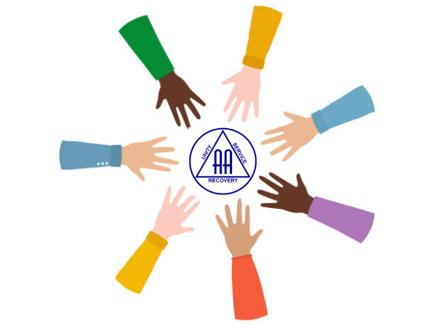

Northeastern MD Intergroup Office
28 Centennial Lane
Aberdeen, MD 21001 Office

Hours: Tues–Fri 10am–3pm
1st Sat of the month 10am–2pm
24-hour Hotline:
1-410-272-4150
email: office@nemdaa.org
website: www.nemdaa.org
A.A. PREAMBLE© Alcoholics Anonymous is a fellowship of people who share their experience, strength and hope with each other that they may solve their common problem and help others to recover from alcoholism. The only requirement for membership is a desire to stop drinking. There are no dues or fees for A.A. membership; we are self-supporting through our own contributions. A.A. is not allied with any sect, denomination, politics, organization or institution; does not wish to engage in any controversy, neither endorses nor opposes any causes. Our primary purpose is to stay sober and help other alcoholics to achieve sobriety. Copyright © The AA Grapevine, Inc.
Reprinted with permission

What is an Intergroup? Contributions And Volunteers
Tradition Seven
"Every A.A. group ought to be fully self-

An Intergroup is an A.A. service office that involves partnership among groups in a community - just as A.A. groups themselves are partnerships of individuals. It is established to carry out certain functions common to all the groups - functions which are best handled by a centralized office - and it is usually maintained, supervised, and supported by these groups in their general interest. It exists to aid the groups in their common purpose of carrying the A.A. message to the alcoholic who still suffers.
Intergroup Functions
The A.A. experience has demonstrated that Intergroups are very important, particularly in populous areas. There are 11 Intergroups in Maryland's Area 29 and over 700 Intergroups or Central Offices functioning throughout the world. These Intergroups form a network of service outlets and A.A. contacts which provide vital services such as:
- Answering inquiries from those seeking help - suffering alcoholics, sober alcoholics, meetings, groups, professionals, and the general public.
- Receiving, arranging, and following up Twelfth Step Calls.
- Publishing local A.A. meeting directories & maintaining websites with A.A. meetings info.
- Communicating via a newsletter or bulletin.
- Exchanging information for local Groups, Areas, and Committees.
- Cooperating closely with GSO and local General Service Area Committees.
- Ordering, selling, and distributing the A.A. Conference Approved Literature.
Intergroups depend upon the local members and groups for support in the form of financial contributions and volunteer help.
- Visit the Intergroup Office - Drop in. Introduce yourself. Chat with staff members and other AAs. This is the "heart line" and first contact for some; and the local information center for the fellowship.
- Communicate with Intergroup - Update your Intergroup with current information about meeting locations, times, and special events.
- 12 Step Volunteer - Sign up to be available to call suffering alcoholics who wish to get sober.

Intergroup Rep. – The rep is the link between the group and Intergroup Council. The rep takes issues back to the group and brings them up at the group conscience. The rep then votes on the issues at the Intergroup Council/business meeting.

Intergroup Committees - Volunteer for Archives, Public Information, Cooperation with the Professional Community, Answering Service, Institutions, Ways & Means, Finance, and Website/Technology.

Participate in Intergroup Events - Help by volunteering; show up for fun and fellowship.

I am responsible ...
When anyone, anywhere, reaches out for help, I want the hand of A.A. always to be there. And for that I am responsible.
supporting, declining outside contributions."
"When we meet and defeat the temptation to take large gifts, we are only being prudent. But when we are generous with the hat, we give a token that we are grateful for our blessing and evidence that we are eager to share what we have found with those who still suffer." Bill W.
Groups may contribute as much and as often as a group conscience decides. Individual members may contribute up to $7,500 yearly through the birthday plan, individual contributions and $12,500 in memoriam.
Tradition Nine
"A.A., as such, ought never be organized; but we may create service boards or committees directly responsible to those they serve."
"... we shall always need to authorize workers to serve us. It is in this spirit of service that we elect the A.A. Group's informal rotating committee, the Intergroup Association for the area, and the General Service Conference for A.A. as a whole."
12 & 12 page 179

Intergroup Council Meetings Northeastern Maryland Intergroup of Alcoholics Anonymous (NEMDAA) holds its Intergroup Council meeting on the 4th Tuesday of every month at 7pm in the NEMDAA Office.
Visitors are Welcome!

