[**versión francesa**](https://docs.google.com/document/d/19bVsjsKnR2-xxcH9sN56msN4wWiRIb9E0Aj5cgc6pBs/edit?usp=sharing)  **&** [**versión en español**](https://docs.google.com/document/d/1nVjfwpZKTYJMrftRVoMrpguB_-qTNyrweTiKBamapVM/edit?usp=sharing)

**Deaf Alcoholics Anonymous** [deafaa.org](http://deafaa.org/)

Find an accessible Deaf Alcoholics Anonymous (A.A.) or

ASL Interpreted Meeting **“TODAY”**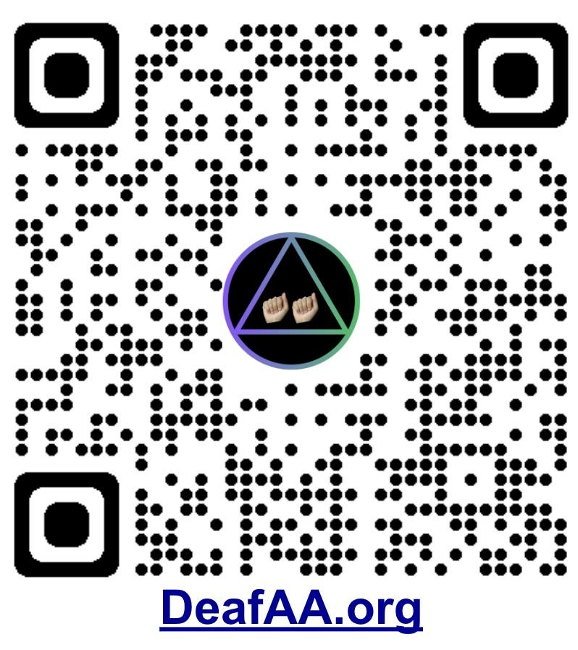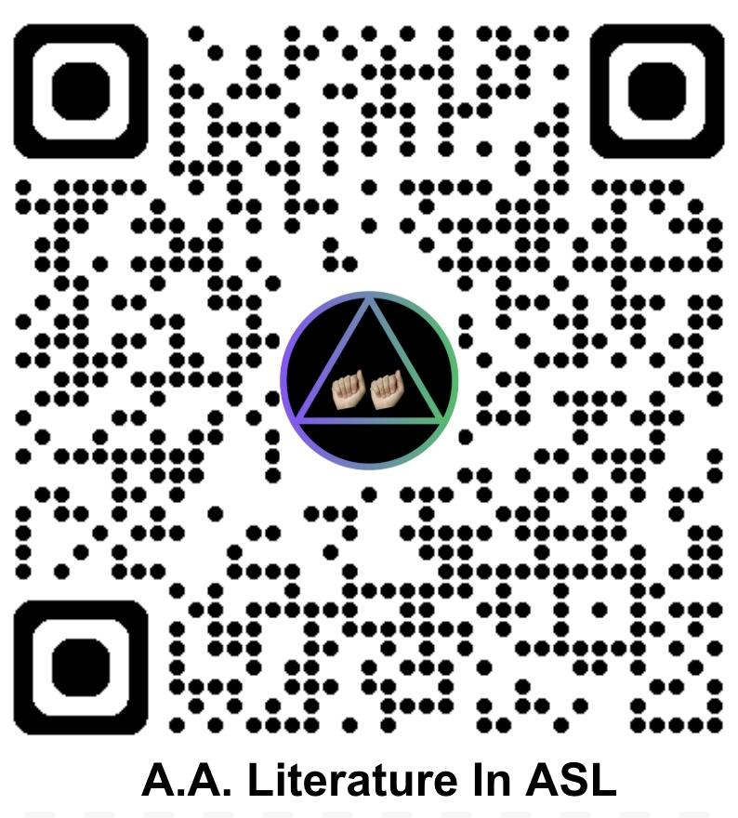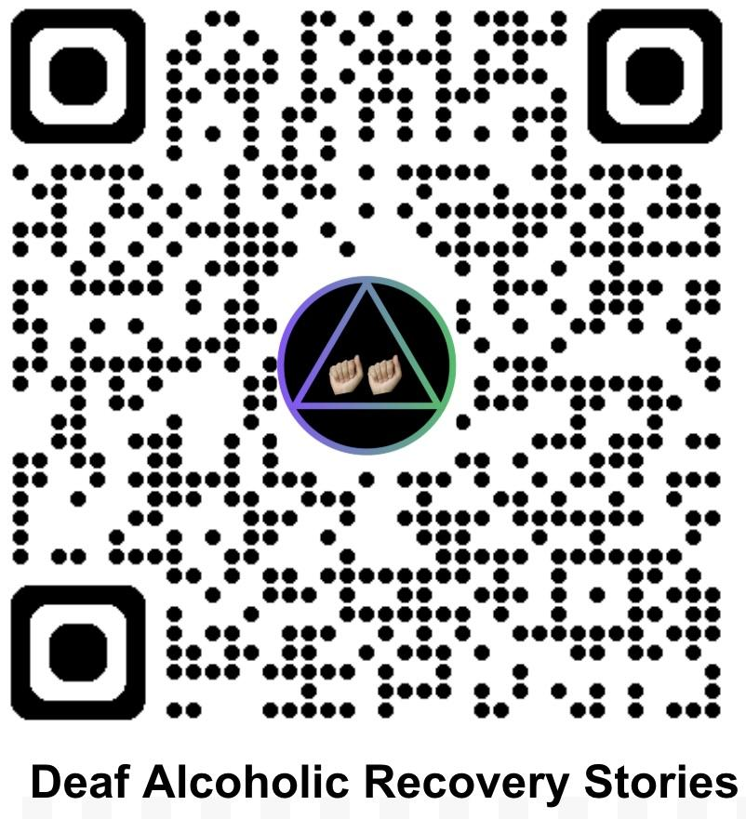

**Find tools for recovery from alcoholism**

* Accessible [Deaf A.A. & ASL](https://deafaa.org) interpreted meetings **everyday** of the week. Find fellowship, a sponsor and service opportunities.
* [Grapevine stories by Deaf alcoholics in ASL](https://sites.google.com/view/deafaa/grapevine-asl-playlist)
* A.A. literature in [American Sign Language](https://sites.google.com/view/deafaa/aa-asl-cc-videos) 
  + [Plain language Big Book TOOL](https://onlineliterature.aa.org/Plain-Language-Big-Book) (English)
* [LSQ](https://sites.google.com/view/deafaa/langue-des-signes-du-qu%C3%A9bec-lsq) Langue des signes du Québec / Quebec Sign Language interpreted meetings.
* A.A. literature available in [LSQ](https://sites.google.com/view/deafaa/langue-des-signes-du-qu%C3%A9bec-lsq) 
  + A.A. literature in [French](https://www.aa.org/fr/resources/literature)
* [LSM Resources](https://sites.google.com/view/deafaa/lengua-de-se%C3%B1as-mexicana-lsm) Lengua de Señas Mexicana / Mexican Sign Language.
* Grapevine stories in Spanish [La Vina Magazine](https://www.aalavina.org/) & [YouTube](https://www.youtube.com/@AAGrapevine/playlists)
* A.A. literature in [Spanish](https://www.aa.org/es/resources/literature) 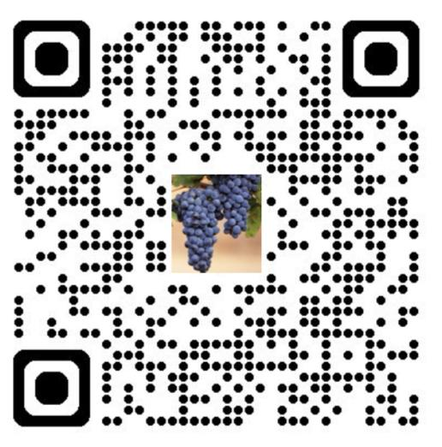

[**Save the Date January 17, 2026**](https://docs.google.com/document/d/1JCoSIE-H8w1gAEpHJterwG3-q7tpxTR1elpVvLOFG8M/edit?usp=sharing)

**Special Forum for Deaf A.A. Members**

**Digital Flyer QR Code**